Family Handbook
2023/2024

New Britain Boys & Girls Club

Our Mission
The mission of the Boys and Girls Clubs of New Britain (The Club) is to enable all young people, especially those who need us most, to reach their full potential as productive, caring, responsible citizens.

Core Programs and Areas
The Club offers nationally recognized and structured programs that engage children in core enrichment areas developed around Education & STEM, Healthy Lifestyles, Good Character, Citizenship & Service Learning, Teen Service & Career Exploration and Arts & Culture.

Student Eligibility
Residents of New Britain who are enrolled in 1st through 12th grade and are between the ages of 6 and 18 years old are eligible to become members of The Club.

Membership Fee
For the School year membership fees are $150 for members in the grades 1 – 8 program. The fee for members entering High School is $100 for the entire year.

Hours of Program Operation
2:30pm – 8:00pm

Emergency
I understand that in the event of a medical emergency, every effort will be made to contact me. In the event I cannot be reached, I authorized the Boys & Girls Club of New Britain (here after known as The Club) and its agents and/or employees to secure emergency transportation and to secure and consent to any and all medical care and treatment for my child as deemed necessary by a qualified medical care provider.

Liability
I understand that The Club is not responsible or liable in any way in the event of harm or injury occurring to my child. It is agreed that I will hold The Club harmless for the actions of my children or the action of other children that result in the harm of others or damage to property, including activities outside of the Club. I authorize The Club to seek medical attention for my child should the need arise. The Club is not responsible for lost, damaged or stolen personal items.

Photo/Video Release
I am giving consent for photographs, videos and/or like materials, in which my son/daughter may appear, to be used in any promotional materials The Club may care to use them.

Release of Information
I am giving permission for the school my son/daughter attends to share attendance information, quarter and semester grades, suspension information and standardized test information with the staff of the Boys & Girls Club of New Britain. This information will be used only by the staff in aggregated data reports and will not be used in any way that could identify an individual student.

Communications
I also consent to being added to the Remind.com database to receive updates from the club via text.

Electronic Use Policy
I understand and will abide by the Electronic Use Policy of The Club as stated in the Parent Handbook. As the parent/guardian, I give permission for my child to use the computer resources at The Club. In addition, personal electronic devises as well as cell phones, are not allow during programming unless the program requires their usage. Should you need to contact your child at the Club, please call the program Director.

Survey
I consent to my child partaking in the NYOI survey as well as any other surveys conducted by the Boys & Girls Club that will be used to track the wellbeing of members in Boys & Girls Clubs locally, regionally and nationally. I understand the survey asks about the attitudes and health behaviors of Club members, including questions about nutrition and physical activity. Teen members aged 13 and older are asked additional questions around alcohol, tobacco and other drug use, fighting, arrests, and whether teens are sexually active.

Emergency Closings
At times, emergencies such as severe weather or power failures can disrupt Club operations. In the event that such an emergency occurs during non-working hours, local radio and/or television stations will be asked to broadcast notification of the closing. In addition, it would be on our website and social media outlets. During bad weather when schools are closed, the Club will be closed. During other emergencies affecting closure of the Club.

Student Attendance
The Boys & Girls Club of New Britain is an afterschool youth development program and a summer camp program that supports the educational goals of each school system. Therefore, members of The Club who have been suspended from school are not allowed to attend the Club until the terms of the suspension have been met or contact with parents have been made.

All students are requested to attend at least three days each week when program is in operations. Families will be contacted if their member(s) is not attending on a regular basis.

We have developed Impact Volunteer Programming which brings in community volunteers who create meaningful connections with our kids by sharing their expertise by planning and implementing a four week program focusing on our pillars: Education & STEM, Healthy Lifestyles, Good Character, Citizenship & Service Learning, Teen Service & Career Exploration, Arts & Culture. If your child enrolls in one of the programs it is important that they attend each program.

Member Pick-up
In order to provide quality programming for our youth we need your help. We are requesting that you pick up your child aged 6-12 by 6:00 pm. Children over 12 must be picked up by 8:00 pm. The Club understand that your child may be involved in outside extra-curricular activities or have appointments, please let us know that information in advance and we will accommodate.

Member must be picked up promptly at the end of program. Pick up after 6:15pm will result in a charge of $1 per minute. If family doesn’t communicate by 6:30pm we will call local law enforcement to arrange for an escort for your child. If picking up late becomes habitual, additional action will be taken.

Members 12 and younger must be picked up from the Club by a parent, guardian or another authorized adult. Members age 13 and older may escort other members of their household from the Club provided they have written permission. Members who leave unescorted without written permission will be subject to disciplinary action, up to and including suspension and termination of membership.

Only persons listed on the Authorized Adult Pick-up Form can sign the child out at the end of the day.

Authorized adults may be asked for a photo I.D. to retrieve the member.

Members who leave the building are not allowed to return unless prior arrangements have been made by families.

Please call immediately, if you will be late due to an unavoidable emergency, to make the Supervisor aware of the situation. Please note this does not exempt you from the late fees.

Dress Code
Students should come to the program in proper attire according to school dress code guidelines. Shoes, preferably sneakers, must be worn at all times unless the program requested them to remove shoes. Due to the active environment at the Club sites, athletic type shoes are required during certain activities. Flip-flops and sandals can cause injury and are therefore inappropriate attire.

Club Rules
Programming, like Expectation Station will be offered weekly to help members develop and understand rules and expectations. The following are the rules of The Club:
- Be Safe
- Be Responsible
- Be Respectful
- Be Kind
- Be Great

Weapons
Any person entering any Club site may not, at any time while on any property owned, leased or controlled by The Boys & Girls Club, including anywhere that company business is conducted, possess or use any weapon outside of law enforcement.

Persons who violate this policy will be subject to disciplinary actions, up to and including membership termination.

Behavior/Conduct
Praise and encouragement are the focus of our program. Positive behavior is always noted, negative behavior is addressed and corrected in a positive manner. We guide and discipline through corrective measures that are in the best interest of everyone involved in the program.

Members will be asked to leave programming for the day when members are suspected of being under the influence, fight with the intent to harm, intentional destruction of property and/or gross disrespect of staff and peers.

Food Policy
Dinner with milk and/or juice will be provided each day the after school program is in operation. It is the parent(s)/guardian(s) responsibility to provide the Director with information regarding foods that their student(s) dietary restrictions. No outside food or drinks may be consumed during programming.

If the parent(s)/guardian(s) want to provide treats for members during special occasions, treats should be commercially produced, purchased and wrapped appropriately. Please notify the Unit Director in advance when providing snacks for a special event.

Medical Conditions
The Club cannot care for sick children. If a member is ill, he /she MUST be picked up after contact has been made with the parent, guardian, or emergency caregiver within 30 minutes of being notified. If the child is ill before leaving home or he/she was not well enough to attend school, please do not bring him/her to the Club. When a child complains of discomfort, injury, or illness, we will make every attempt to notify the parent. A child must be able to participate in the program to attend the Club.

Parent(s)/guardian(s) should provide the Executive Director with information regarding members medical conditions.

Medication Policy

No medication (prescription or over the counter) will be administered at any Club with the following exceptions:

- Asthma Inhaler
- Epi-pen

If you child requires medication, it is your responsibly to provide it to them.

Transportation Policy
The School will provide transportation for youth enrolled in or programs by order of registration If a member chooses to break a rule, they will not be able to ride the bus. Please understand that transportation at the Club is a privilege.

Bus Rules
I understand and will abide by the Bus Rules for The Club. I understand that riding the school bus is a privilege. Boys & Girls Club refers to riding a school bus as an “entitlement” which means that we are not required to provide transportation for any student who does not meet behavior expectations.
- Members must always be respectful to the driver and their peers
- No eating or drinking allowed
- Members must keep hands and all body parts inside the windows
- Members must be quite at the railroad crossings
- Members must remain seated until the bus stops
- Members may not open or attempt to exit through the emergency doors
- Members must follow all Club rules while riding the bus.

SMART Programming
As part of the optimal club experience your child will be participating in The Club’s SMART LEADERS programs. The SMART (Skills Mastery and Resistance Training) programming including SMART Moves and SMART Girls. Participants will be exposed to various activities designed to hone their decision-making and critical thinking skills, as well as learn how to avoid and/or resist alcohol, tobacco, other drugs and premature sexual activity. The program will address positive, healthy body images healthy lifestyles including diet, exercise, and personal hygiene; physical and emotional growth associated with puberty including but not limited to sexually transmitted diseases, sexual truths and myths, menstruation, and the importance of regular exams; other questions boys and girls have will also be addressed with an appropriate staff member and/or brought to your attention when necessary. The programs are designed to targeted effort to engage young boys and girls in discussions activities that reinforce positive behavior.

Parent(s)/Guardian(s) Responsibilities
Parent(s)/Guardian(s) are responsible for reviewing the parent handbook with their student(s) and assisting program staff with enforcing these guidelines.

Parents are requested to attend monthly Family Engagement Activities during the duration of the program, provided their child is still enrolled in the program.

Parents may be asked to participate in a survey. All information will remain confidential and used for purposes identified on the signed Parent/Guardian
Informed Consent Form.

General Disclosures
- Non-license/Exempt Parental Notification: The operations of The Club programs are exempt and not licensed childcare or regulated by licensing requirements.
- Not Compensation-based Care: The Club does not collect compensation based on the number of visits or on a weekly, monthly, or other such periodic basis, for members K – 5 a one-time, nominal, annual membership dues, late fees or program service fees for special activities.
- The Club’s Affiliation with BGCA: The Clubs are affiliated with and in good standing with a national organization and sites are regularly reviewed for quality and organizational excellence.
- Board-Adopted Internal Operating Standards: The Club Board has adopted standards of operation including health/safety standards and mechanisms for assessing/enforcing compliance.
- Health and Safety Code Compliance: The Club will comply with applicable, local, regional and state health department, state fire marshal and local fire prevention guidelines and requirements and will retain on premises at all times records of those inspections.
- Criminal Background Checks: The Club requires all employees/volunteers undergo (national) criminal history background checks and DCFS background check.
- Child Abuse Reporting: As Mandated Reports, all The Club staff members will report known or suspected child abuse.
- Parental Complaint Receipt/Resolution Process: The Club will provide a process to receive and resolve parental/guardian complaints.
- Transportation Authorization: The Club is allowed to transport your child for fields trips during regular program hours. Parent authorization is required for trips outside of regular scheduled program time.

Disclosure of Federal Participation (Stevens Amendment)
Projects or programs funded in whole or in part with Federal grant money must credit the Federal government for the Federal government's portion of the financial support. This handbook citation informs the public that the use of Federal dollars for the 21st Century Program partnership between New Britain Schools and The Boys and Girls Clubs of New Britain meets the Stevens Amendment requirement. Staff development opportunities, resource purchases and personnel have been funded in whole or in part with Federal entitlement dollars.

Scan QR for Boys & Girls Club of New Britain’s Policies for the Protection of Youth
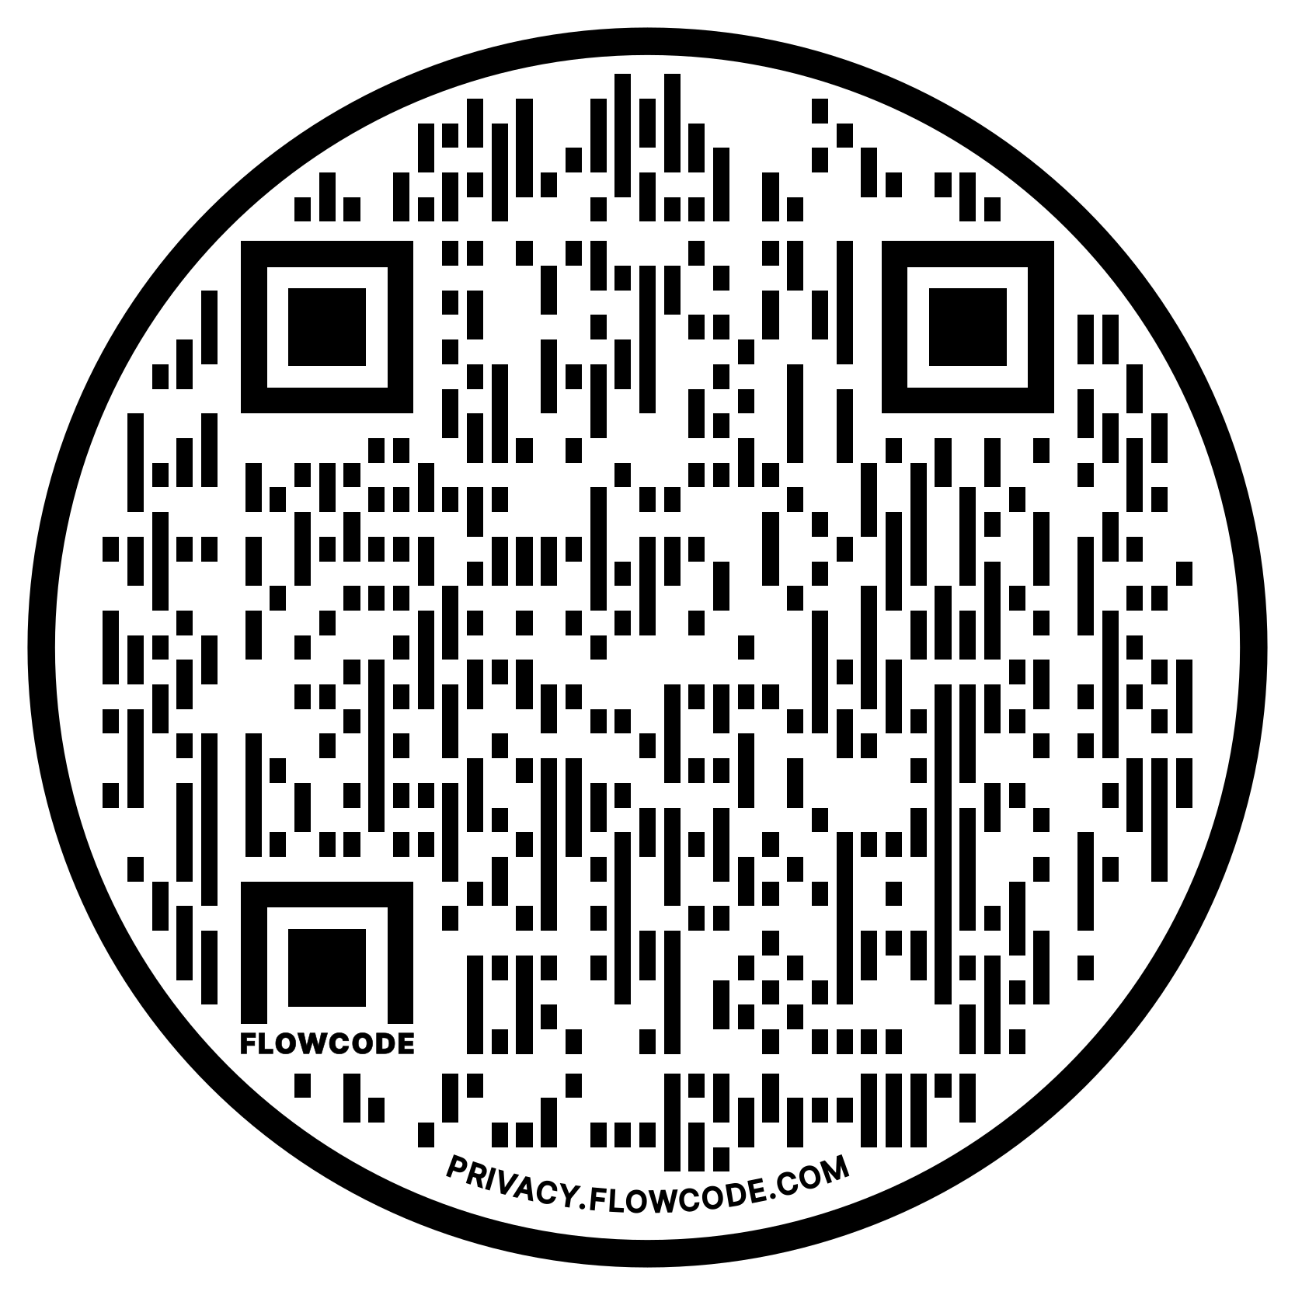
Special Addendum During COVID-19 Pandemic
Boys & Girls Club of New Britain is operating under a “new normal” during these challenging times. Just know that our first priority is the safety of your child and our team. The safety protocols will be followed as recommended by the Center for Disease Control & Prevention (CDC), our local Health Department and our Insurance Company. The policies outlined below are based on their guidelines and will be enforced at the Club throughout the summer. Everything implemented is only meant to protect your child.
We have carefully considered the risks of our Clubs opening, as well as the risks of disruption to essential service providers in our community. We believe that reopening will fill a critical need to the community. Boys & Girls Club of New Britain will remain vigilant to protect the wellbeing of the members and staff.
There will be no additional fees for members. School year membership will be $150.00. We will continue to accept new memberships and they will be put on a waitlist. As soon as space opens up we will contact you.
If you are able to work from home or have a safe place for your child to stay, please do not sign up for this service. If we have too many children signed up, priority will be given to the children of employees providing essential services in the community and low-income members. As recommended, if you or your child is sick, please keep them home.
Please be aware of some prevention measures we are instituting:
- Other than staff, only children will be allowed in the building (drop off & pick up will be held outside the doors).
- Before entering the building all staff & youth will have their temperature taken. Children’s temperature will be recorded throughout the day. If your child develops a temperature of 99.5 or more during the day you will be called immediately. You must arrange for your child to be picked up within 30 minutes of notification.
- Handwashing and/or hand sanitizing will be implemented every 30 minutes throughout the program day.
- Social distancing practices as well as limited physical contact we will be implemented at the Club.
Youth Interactions at the Club
- Avoid physical contact such as hugging, high fives, or fist bumps.
- While we strive to provide a caring and nurturing environment, best practice under these circumstances is to discourage physical contact.
- Provide staff facilitated lessons on safety measures and educate Club members about playing an active role in slowing the spread of COVID- 19.
- Maintain an ongoing dialog with Club members; this information may be scary for them, so provide a safe place for them to express their fears.
- Personal Hygiene: It is the responsibility of every member to practice recommended hygiene procedures.
  - Cover cough or sneeze with a tissue, then throw the tissue in the trash.
  - Avoid touching eyes, nose, and mouth.
  - Wash hands often with soap and water for at least 20 seconds. If washing hands is not practical, use hand sanitizer.
Please talked to your child(ren) about these new policies before they come to the Club. We want everyone to understand our expectations upon entering. We will also be talking with them about the new polices throughout the summer.

Drop off & Pick Up Procedures
Parents will pick up outside of the Club, remaining in their cars and calling 860-229-2865 when you are outside. Please remain in the car and parked as we complete a wellness check on your child and they enter the building. Do not leave until your child has entered the building. Please be aware you will need to allow for extra time. We will move as quickly and safely as possible.
A staff member will:
- Screen your child(ren) prior to them entering the building by taking and recording your child(ren)’s temperature. We will record the time & date of the temperature each time at lunch time and snack.
- Child(ren) will be immediately taken to wash their hands following CDC recommendations and then sent to their program area. All children will remain in one classroom throughout the day. Breakfast, lunch, and snack will be served in that space. Time outside will be allocated each day, weather permitting.
- When picking up please remain in vehicle. Call 860-229-2865 requesting your child(ren) be sent out. Be prepared to show an ID card or we may give you a card that will need to be visible from the front door. Put this in your passenger side window.
- Once authorization of pick up is verified, we will release your child(ren) to you. Please note, your child(ren) will not be released to an individual that is not on the authorized pick up list with appropriate ID. You must call if you are requesting anyone not on the list to pickup.
- Please pickup before 7:00pm. The late policy as outlined above is still in effect.

What We Request from You as a Parent/Guardian
- Follow the new policies outlined in this special addendum.
- Prepare your child for these changes.
- Communicate with us daily, let us know if anyone at home may be showing signs/symptoms of any respiratory infections such as a fever, dry cough, shortness of breath, or chills.
- If anyone has traveled outside of McLean County.
- Notify us immediately if anyone in your household has tested positive for COVID-19.
- Communication between families and the Club will be done over the phone and/or via Zoom. Parents will not be allowed in the building at this time.
What to bring to the Club?
- Healthy happy child(ren) with a light jacket (if needed) and a smile
What not to bring to the Club
- Backpacks
- Lunchboxes
- Personal property including cell phones, tablets, chromes, and/or any other personal items. At your own risk*****
Please note we will provide your child with breakfast, lunch and snack. We have individual supplies (crayons, markers, pencils, scissors, glue sticks, etc.) for each child. We are unable to uphold our cleaning, prevention, and sanitization procedures if items are brought in that we are not aware of. Please leave all toys, fidgets, etc. and other items at home.
PPE Guidelines
All students must have a mask in case they need to move around or have an emergency.
Procedures for child(ren) and/or staff who are sick during Club hours
- If your child(ren) develops a fever of over 99.5 at the Club, we will notify you immediately and separate the youth with a staff member until you pick them up.
- You will be required to call your health care provider to discuss your child’s symptoms and possibly see the health care professional.
- A Doctor’s note is required noting that the child(ren) is cleared to return to the Club.
- If you, your child or anyone in the home has tested positive for COVID-19, please notify us immediately so we can follow the proper protocols and notify the Bloomington-Normal Health Department.
- Follow self-isolation recommendations as provided by the CDC.
- If a family member or if you or your child has been in contact with a confirmed case of COVID-19, self-quarantine for 14 days and do not return to the Club until after the 14-day quarantine.
Confirmed Case at the Club
We will implement short-term closure procedures regardless of community spread if an infected person has been in our building. If this happens, CDC recommends the following procedures regardless of the level of community spread:
- Coordinate with local health officials. Once learning of a COVID-19 case in someone who has been in the Club we will immediately notify the local New Britain health officials. These officials will help us determine a course of action for our childcare program.
- Dismiss your child(ren) and most staff for 2-5 days. This initial short-term dismissal allows time for the local health officials to gain a better understanding of the COVID-19 situation impacting the Club. This allows the local health officials to help us determine appropriate next steps, including whether an extended closure duration is needed to stop or slow further spread of COVID-19.
- Local health officials’ recommendations and duration of Club dismissals will be made on a case-by-case basis using the most up-to-date information about COVID-19 and the specific cases in the community.
- Discourage staff, students, and their families from gathering or socializing anywhere. This includes group childcare arrangements, as well as gathering at places like a friend’s house, a favorite restaurant, or the local shopping mall.
- Communicate with staff, parents, and Club members. Coordinate with local health officials to communicate closure and closing decisions and the possible COVID-19 exposure.
- At the initial sign-up we asked you to sign up for Remind, we will contact you through Remind and/or call you directly.
- This communication to the community will align with the communication plan in the Club’s emergency operations plan.
- We plan to include messages to counter potential stigma and discrimination.
- In such a circumstance, it is critical to maintain confidentiality of your child(ren) and/or staff member as required by the Americans with Disabilities Act and the Family Education Rights and Privacy Act.
- Clean and disinfect thoroughly.
- We will close off areas used by the individuals with COVID-19 and wait as long as practical before beginning cleaning and disinfection to minimize potential for exposure to respiratory droplets. Open outside doors and windows to increase air circulation in the area. If possible, wait up to 24 hours before beginning cleaning and disinfection.
- Cleaning staff shall clean and disinfect all areas (e.g., offices, bathrooms, and common areas) used by the ill persons, focusing especially on frequently touched surfaces.
- Make decisions about extending the Club closure length. Temporarily dismissing childcare programs is a strategy to stop or slow the further spread of COVID-19 in communities.
- During Club closure (after cleaning and disinfection), childcare programs may stay open for staff members (unless ill) while students stay home. Keeping facilities open: a) allows staff to develop and deliver virtual programming remotely, thus maintaining continuity of learning; and b) allows other staff members to continue to provide services and help with additional response efforts. Decisions on which, if any, staff should be allowed in the Club shall be made in collaboration with local health officials.
- The Board of Directors and CEO shall seek guidance from local health officials to determine when child(ren) and staff should return to the Club and what additional steps are needed for the community. In addition, Club members and staff who are well but are taking care of or share a home with someone with a case of COVID-19 shall follow instructions from local health officials to determine when to return to the Club.
We know this “new normal” is a big transition and we thank you for entrusting your child(ren) with us. Please read this entire document as our policies before COVID-19 are still in effect as well including our medication policy and emergency medication procedures.
Our first call in an emergency is 911 and then we will notify you if your child(ren) are in an emergency situation. As always contact our Director of Programming, Director of Operations or Executive Director with any questions or concerns.

Thank you for your cooperation
James M. Jones
Executive Director

